/  /  Sept. 2nd  Happy hour hang out  Meet your board and fellow CPCUs  This is a very informal event. Come hang with us at the patio behind Bourbon St. and The Bowery. Have a drink or grab a bite and enjoy great networking with other CPCUs. This is an opportunity to meet new members of our chapter and catch up with old friends.  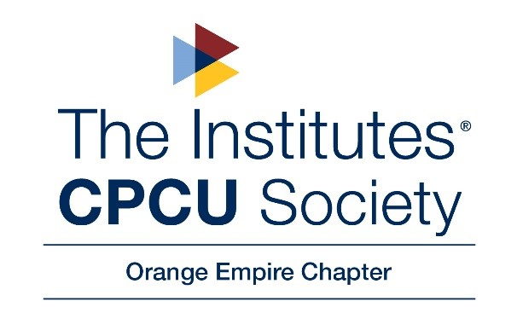 | FREE TO ATTEND  ────  Come meet your board and fellow CPCUs  ────  Bourbon St. and the Bowery in Downtown Fullerton  ────  5:30-7:30pm  ────  Both establishments have good food and drinks for purchase  Bourbon st/ The bowery  110 E. Commonwealth Ave, Fullerton, CA 92832  Any questions:  orangeempirecpcu@gmail.com

